Lab 8: Video Memory and String Instructions
Learning Outcomes

- Students will be able to write characters directly to video memory.
- Students will be able to translate screen coordinates into linear memory addresses.
- Students will be able to declare strings and display them on screen using loops.
- Students will be able to copy strings using string instructions.
- Students will know how OS displays messages on screen.

Video Memory

The text screen video memory for color monitors resides at 0xB8000. The text screen resolution is 80 x 25, which means that there are 25 rows, and each row has 80 characters, therefore, there are 2000 characters. Each character requires 2 bytes of information. One byte is for the ASCII code of character that is to be displayed on screen, and the other byte is for the attributes associated with that character. Attributes contain the foreground and background colors of the character. The first nibble (4 least significant bits) is reserved for foreground (text) color, and the second nibble (4 most significant bits) is reserved for background color. Each character's background and foreground colors can be set or obtained by reading a specific byte from memory.

Attributes
The various fields of the byte reserved for attributes are shown below. RGB are red, green, and blue colors. ‘I’ is the intensity of the color, and ‘B’ is for blink.

Background Color |  |  |  | Foreground Color
B | R | G | B | I | R | G | B
Blink | Red | Green | Blue | Intensity | Red | Green | Blue

The following table shows the 4-bit color combination.

I/B | R | G | B | Color
0 | 0 | 0 | 0 | Black
0 | 0 | 0 | 1 | Blue
0 | 0 | 1 | 0 | Green
0 | 0 | 1 | 1 | Cyan
0 | 1 | 0 | 0 | Red
0 | 1 | 0 | 1 | Magenta
0 | 1 | 1 | 0 | Brown
0 | 1 | 1 | 1 | White
1 | 0 | 0 | 0 | Gray
1 | 0 | 0 | 1 | Light Blue
1 | 0 | 1 | 0 | Light Green
1 | 0 | 1 | 1 | Light Cyan
1 | 1 | 0 | 0 | Light Red
1 | 1 | 0 | 1 | Light Magenta
1 | 1 | 1 | 0 | Yellow
1 | 1 | 1 | 1 | Bright

Example#1:
Program to write “HELLO” on screen in red color with yellow background.
.model small

.stack 100h

.data

.code

Mov ax,0xb800 Mov es, ax Mov si,0

Mov es:[si], ‘H’ Inc si
Mov byte ptr es:[si], 11100100b Inc si
Mov es:[si], ‘E’ Inc si
Mov byte ptr es:[si], 11100100b Inc si

Mov es:[si], ‘L’ Inc si
Mov byte ptr es:[si], 11100100b Inc si

Mov es:[si], ‘L’ Inc si
Mov byte ptr es:[si], 11100100b Inc si

Mov es:[si], ‘O’ Inc si
Mov byte ptr es:[si], 11100100b Inc si

.exit

Screen coordinates to linear address conversion

The screen is two-dimensional, having rows and columns, while the memory containing the screen's contents is linear. Each character on a screen has a row and column address, which is represented as (row, column), which can be translated to a linear memory address by using the following equations:

Equation 1 finds the linear address of the memory location where the ASCII code of the character to be shown on screen will be stored.

Equation 2 finds the linear address of the memory location where the character's screen attributes will be stored.

This linear address will be added to the base address, i.e., 0xB8000, to form the physical address.

Linear Address (ASCII) = 2 * (Row address * Columns per Row + Column address) (eq. 1) Linear Address (Attributes) = 2 * (Row address * Columns per Row + Column address) + 1 (eq. 2)
Here,
Number of rows = 25 Columns per Row = 80
Since there are 80 columns in each row.

Example:

To display a text on the middle of the screen, we need to know its screen coordinates which are (12,40). These coordinates can be translated into physical address by using equation 1 as shown below.

Memory Address = 2 * (12 * 80 + 40) = 2000 (eq. 3)

Similarly, the offset address of the attributes of center character is

Memory Address = 2 * (12 * 80 + 40) +1 = 2000 + 1 = 2001 (eq. 4)

Example#2:
Program to write “HELLO” on center of the screen.
.model small

.stack 100h

.data

.code

Mov ax,0xb800 Mov es,ax
Mov si,2000
Mov es:[si], 'H' add si,2
Mov es:[si], 'E' add si,2
Mov es:[si], 'L' add si,2

Mov es:[si], 'L' add si,2

Mov es:[si], 'O'

.exit

Defining Strings

Strings are defined using a byte array as shown below.

Msg db “Hello World”

A string is terminated by a character which can be NULL or ‘$’ so that the procedure handling string could know that the string has been ended. Since we are going to define our own code to process strings, therefore, we will place 0, i.e., NULL character at the end of a string as shown below.

Msg db “Hello World”,0

Here ‘,’ is the concatenation operator. It will concatenate strings on its both sides to form a single string.

Example#3:
Program that defines a string and displays it through loop/ jumps.

.model small  .stack 100h  .data  msg db "Hello World",0  .code  mov ax,@data mov ds,ax  Mov ax,0xB800 Mov es,ax  Mov di,0  mov bx,offset msg mov si,0  display:  mov al, [bx+si]  ; mov one character from array to al cmp al,0  ; compare is that character is null  je end ; if null, terminate loop mov es:[di],al  ; Otherwise, mov that character to video memory  add di,2  ; add 2 to di, skipping the attribute part inc si  ; inc si to access the next character of array jmp display ; iterate loop  end:  .exit | .model small  .stack 100h  .data  msg db "Hello World" len equ $- msg  .code  mov ax,@data mov ds,ax mov cx,len  Mov ax,0xB800 Mov es,ax  Mov di,0  LEA BX, msg  ; LEA stands for Load Effective Address  ; same effect like this instruction (mov bx, offset msg)  mov si,0 display:  mov al, [bx+si]  ; mov one character from array to al mov es:[di],al  ; mov that character to video memory  add di,2  ; add 2 to di, skipping the attribute part inc si  ; inc si to access the next character of array loop display ; iterate loop  end:  .exit

String instructions

The following instructions facilitate programmers in moving strings from one memory location to another and comparing strings.

Instruction | Operands | Operation
LODSB  Also see: LODSW | No operands | - AL = DS:[SI]  - if DF = 0 then  - SI = SI + 1  else  - SI = SI – 1
STOSB  Also See: STOSW | No operands | - ES:[DI] = AL  - if DF = 0 then  - DI = DI + 1  else  - DI = DI – 1
MOVSB  Also See: MOVSW | No operands | - ES:[DI] = DS:[SI]  - if DF = 0 then  - SI = SI + 1  - DI = DI + 1  else  - SI = SI - 1  - DI = DI – 1
SCASB  Also See: SCASW | No operands | - AL - ES:[DI]  - set flags according to result:  OF, SF, ZF, AF, PF, CF  - if DF = 0 then  - DI = DI + 1  else  - DI = DI - 1

Example#4:
Program to write “Hello world” on screen using string movement instructions.
.model small

.stack 100h

.data

msg1 db "Hello World",0 msg2 db 12 dup(?)

.code
mov ax,@data mov ds,ax mov es,ax
Mov si,offset msg1 Mov di,offset msg2
; moving offset of msg1 to SI
; moving offset of msg2 to DI
mov cx,11
; initializing counter to iterate loop 11 times
copy: movsb
; copying msg1 to msg2
loop copy
.exit

Emu8086 Tutorial Step by Step Step-1
Double click on the icon on the desktop 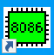

Step-2
The following window will appear. Click on “new”.
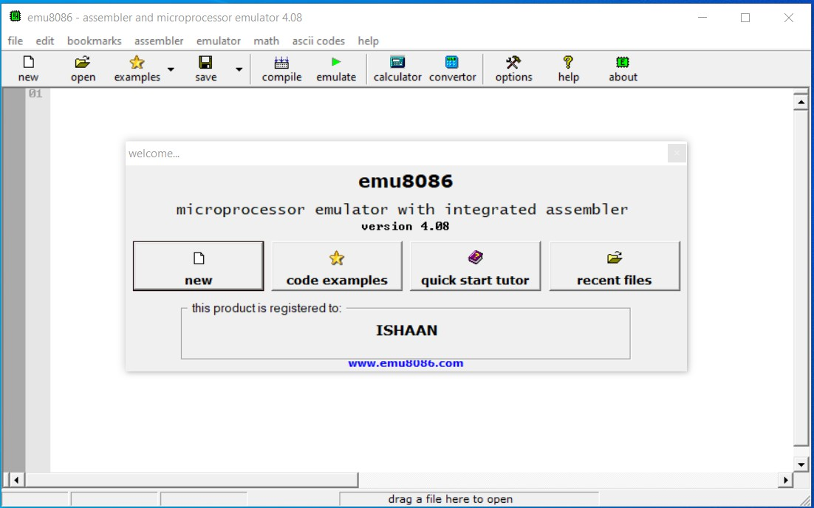

Step-3:
Click on the “empty workspace” and press “OK”.
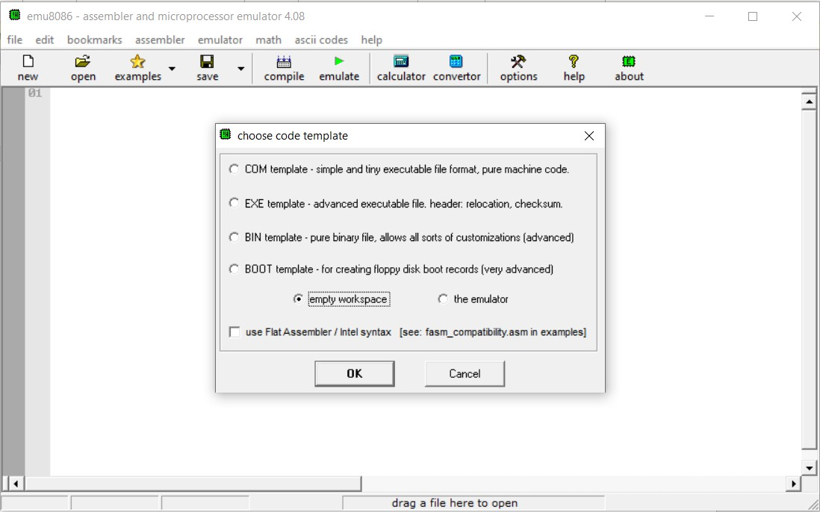

Type the code given in example#3 and click on “emulate”.
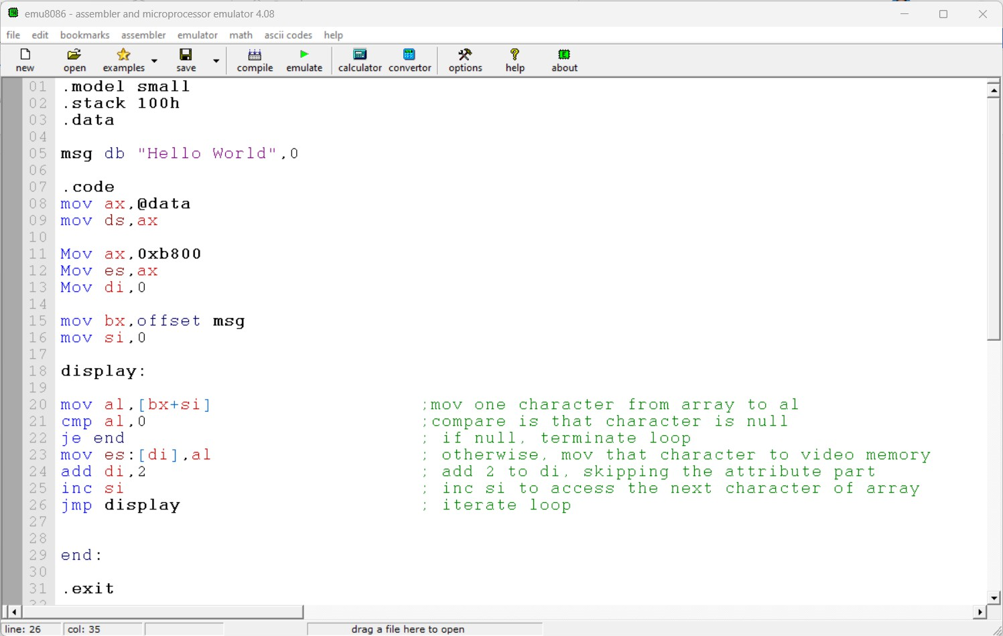

Step-5:
Click on the screen button.
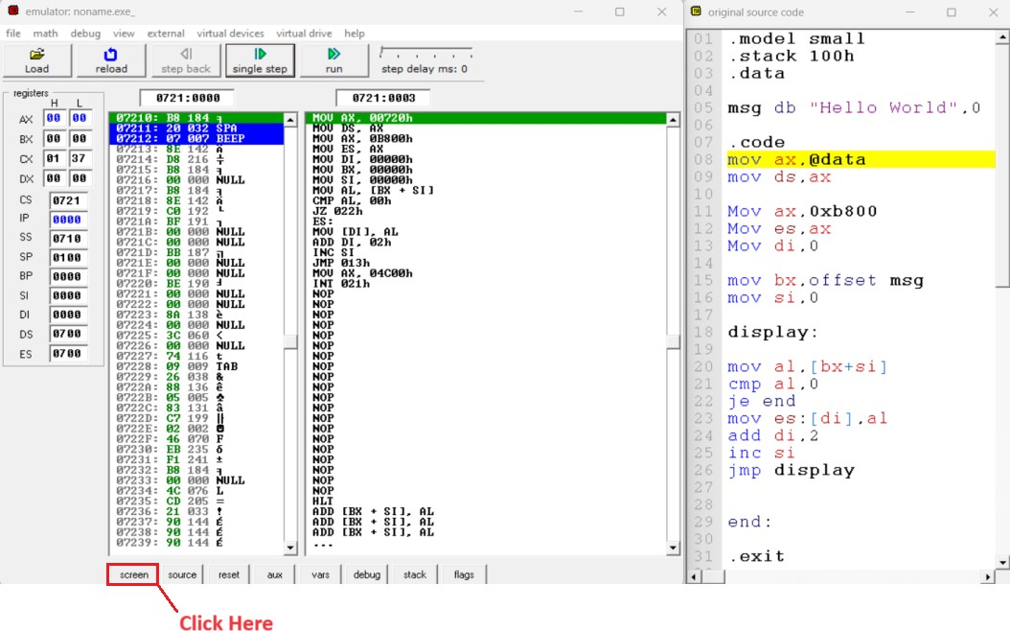

Step-6:
Keep clicking on “Single step” and observe the working of the program.
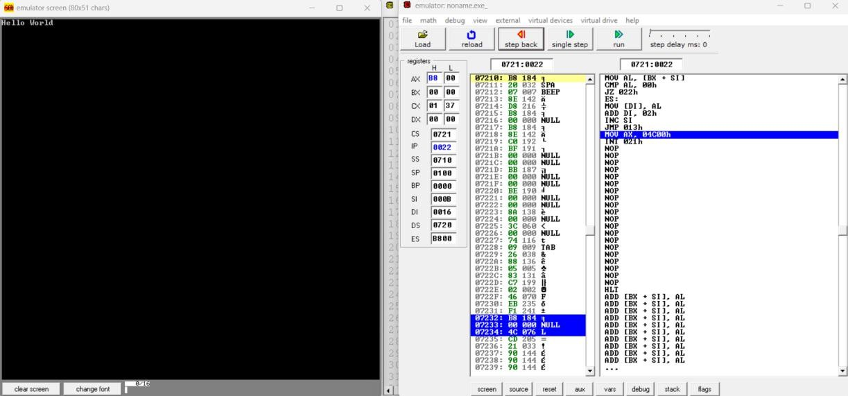

Lab-8 Exercise

Task-1
Write a procedure named "print" that takes a null-terminated string as a parameter and displays it on the screen at the position of the cursor. The cursor increments accordingly whenever a string is displayed. (Hint: You need to keep cursor information in a global variable.)

Task-2
Newline, carriage return, and tab characters are not displayed, but they instruct the display function to perform specific operations. The newline character moves the cursor to the next row in the same column, while carriage return moves the cursor to the first column of the current row. Similarly, the tab character inserts eight spaces.
Add the functionality of newline, cret, and tab to the print procedure you created in task
1. (Hint: See ASCII code of these characters from ASCII table)

Task-3
There are 25 rows from 0 to 24 and 80 columns in a row from 0 to 79. When a column address reaches 80, it is reset to 0, and the row is incremented by 1. When the row address reaches 25, the screen moves up one line, called "scrolling up."
Incorporate the functionality of scroll up to the print procedure you created in task 1. The C++ code for scroll up is given below:

